

2. Executive Summary and Architectural Drivers

2.1 Executive Summary
EcoGrid is an enterprise-grade distributed smart grid energy management system that tackles today's challenges of decentralized energy infrastructure. As the power networks shift towards renewable Distributed Energy Resources (DERs), such as solar systems for house, battery storage and micro-wind turbines, traditional centralized power networks are exposed to severe high load volatility and operational difficulties. EcoGrid does this by combining high frequency IoT smart meter telemetry intake, real time, peer-to-peer (P2P) energy market trading, and automated, audit compliant financial settlement into a highly resilient software architecture.
2.2 The Vision
The vision of EcoGrid is to create a sustainable, transparent and self-balanced energy ecosystem. The platform will allow consumers and prosumers (users of energy producers) to directly launch an surplus of renewables onto the market, and to give network operators visibility to the real-time telematics. EcoGrid's tight domain restrictions and modular separation of high volume IoT data from financial accounting and market order execution guarantees that high volume IoT data never threaten financial accounting or the execution of orders on the market.
2.3 Architectural Drivers
Business Goals
- Decentralized Energy Optimization: Facilitate peer-to-peer (P2P) energy trading and supplier-to-consumer energy trading to optimize energy use from renewables at the local level and minimize transmission losses on the grid.
- Automated & Trustworthy Financial Clearing: Ensure financial clearing for all prosumers and utility providers in an automated, transparent and audit-ready way without manual reconciliation.
- Grid Stability & Operational Intelligence: Ensure operational visibility across the grid in real time and identify anomalies, prevent localized voltage spikes, and balance microgrid loads.
- Maintenance of the Fuel System Elements:Maintenance of the Fuel System Elements:
- IoT Telemetry Ingestion & Device Validation: Ingest, authenticate and validate high frequency device usage data (voltage, active power, current, kWh) from edge smart meters.
- Marketplace Order Matching & Spot Pricing: Keep dynamic energy order books, calculate spot tariffs in real-time according to market demand and handle automatic order matching of trades.
- Billing, Invoicing & Ledger Management: Convert verified usage readings and executed trades into and generate ACID compliant financial debits & credits, invoices and automated payouts.

Quality Attribute Scenarios (ISO/IEC 25010)
Scenario ID | Quality Attribute | Source | Stimulus | Artifact | Environment | Response & Measure
QAS-01 | Scalability / Throughput | 100,000 active IoT smart meters | Peak reporting burst ($100,000msg/sec$) | Smart Meter Integration Context | Normal peak grid operating hours | Authenticate, buffer, and persist telemetry without packet loss. Ingestion lag $<500ms$ at $p99$; $0\%$ telemetry payload loss rate.
QAS-02 | Data Consistency / Reliability | Marketplace Context | Concurrent clearing of 50,000 settlement jobs | Financial Settlement Context | Scheduled billing clearing window | Ledger updates are idempotent, ACID compliant, $100\%$ atomic, $0\% ledger drift and a complete audit log is recorded.
QAS-03 | Performance / Latency | Prosumer trading agent | Submitting dynamic spot order during tariff shift | Marketplace Context | Volatile trading market window | Match order against liquidity pool and update order book. Execution latency $<200ms$ ($p95$).
QAS-04 | Security / Authenticity | Rogue / compromised edge device | Attempting to inject spoofed telemetry payload | API Gateway / Smart Meter Context | Production operating environment | Authenticate via mTLS, sever rogue connection, block payload. Cut connection $<50ms$; $0\%$ invalid packets accepted.

3. Domain Decomposition

3.1 Bounded Contexts
The Domain-Driven Design (DDD) concepts are used to break down the EcoGrid platform into the following three main Bounded Contexts. This architectural separation gives operational isolation, high cohesion of domain modules and prevents high-speed hardware streaming from affecting the integrity of financial transactions.

Architecture Diagram: Bounded Context Boundaries
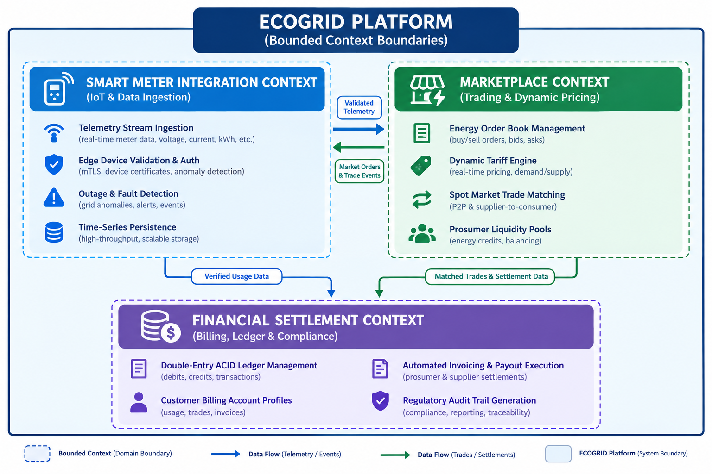

Detailed Domain Boundaries and Responsibilities

1. Smart Meter Integration Context
- Integral Responsibilities:
  - Eating a lot of raw usage information (kWh, active power, voltage) sent in real-time and high volume from physical IoT edge smart meters.
  - Avoiding spoofed or corrupted meter payloads through the use of hardware mTLS authentication and data validation.
  - Identify physical grid anomalies, such as sudden voltage drops, power failures and send alerts to operational dashboards.
- Domain Boundary: This context is limited to the physical integration of hardware, communication of edge protocols and raw telemetry persistence. It has no business logic code for energy pricing, trading rules etc. or financial billing.

2. Marketplace Context
- Core Responsibilities:
  - Continuous management of the order book for energy supply/customer spot market bids/offers from prosumers, consumers and energy suppliers.
  - Calculation of spot energy tariff in a dynamic way, using microgrid supply-demand balance in local areas.
  - Programming order matching algorithms for price preferences, energy source type and region grid nearness.
- Domain Boundary: This context applies to the rules of trading in the market, as well as rules for matching the execution of a trade. It uses the data gathered from usage collected by the Smart Meter context to check trade fulfillment, without controlling the physical edge hardware and bank payout.

3. Financial Settlment Context
- Integral Responsibilities:
  - To guarantee that marketplace transactions and meter readings are accurately recorded as financial transactions.Correctly converting marketplace transactions and meter checks into financial transactions (debits and credits).
  - Customer billing accounts management, creation of periodic billing and automatic outside bank/wallet payments.
  - Ensuring a 'watershed' financial ledger that is 'immutable,' helping to meet regulatory requirements and audit needs.
- Domain Boundary: All transactions in this context are strictly transactional consistent (ACID guarantees). It is 100% independent of high volume telemetry streaming feeds to shield financial records from network peaks or delays.

Rationale for Domain Boundaries
- Isolation of Concerns: High frequency smart meter reads (100,000events/sec) create work loads with lots of writes. By separating out this ingestion pipeline, telemetry spikes can't lock financial databases, pause order matching in real time, etc.
- Context-Specific Domain Models: There is a separate domain model for each and every context. For instance:
  - A Meter is a physical hardware device with a unique MAC address, firmware version and calibration spec in the Smart Meter Integration Context.
  - That same Meter is just a billing endpoint with association to a customer account ID, tariff schedule and tax identifier in the Financial Settlement Context.

7. AI-Assisted Design Portfolio (Member 1 Contribution)

Member 1 Prompt Engineering & Refinement Log
Iteration Stage | Prompt / Refinement Summary | AI Output Summary | Key Architectural Refinements
Initial Prompt | Asked for key architectural drivers and NFRs for the EcoGrid platform. | Standard list of basic scalability, availability, security and performance. | Presented some requirements, but first results were very general for smart grid infrastructure.
Refinement 1 | Improve the drivers specifically for EcoGrid - Business Goals, Functional Requirements, Quality Attributes. | Differentiate needs into high frequency IoT streaming, energy trading, and audit settlement. | Substituted out general Web Application ideas with energy area challenges and bounded contexts.
Refinement 2 | Include engineering measures (100,000msg/sec, <500ms lag) on Quality Attributes. | Defined quantitative operational targets and consistency requirements. | Converted qualitative descriptors into verifiable quantitative targets required for architecture evaluation.
Refinement 3 | To create four Quality Attribute Scenarios in formal ISO/IEC 25010. | Created formal QAS tables identifying the Source, Stimulus, Artifact, Environment, Response and Response Measure. | Common documentation as per enterprise architectural presentation standards.

Critical Evaluation of Generative AI Assistance
The answer that the Generative AI machine came up with was too generic and could have been for any web application. It did not consider the special architectural needs of smart grid infrastructure, including the significant differences between event streaming (high throughput) and clearing (ACID-based transactions).
The AI was then prompted in a specific and iterative way to produce specific results for the domain. The domain boundaries were specified in Refinement 1, quantitative performance requirements were specified in Refinement 2 and the requirements were converted to standard ISO/IEC 25010 Quality Attribute Scenarios in Refinement 3. This was an iterative process that meant that the final design drivers were actionable, and gave precise parameters that informed the architecture that was to come down the line.

Final Validation
The elegant architectural motivators are precisely what are faced in the real world with an enterprise smart grid platform. They define strict limits which directly influence the choices of an Event-Driven Architecture (EDA) to process the telemetry streams and a financial transactions ledger which is decoupled and ACID compliant.

Appendix
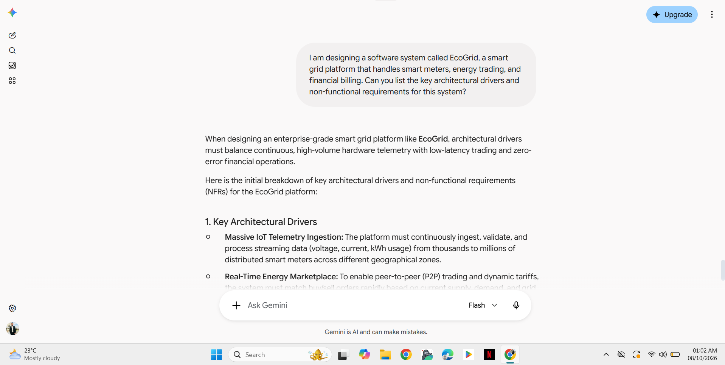

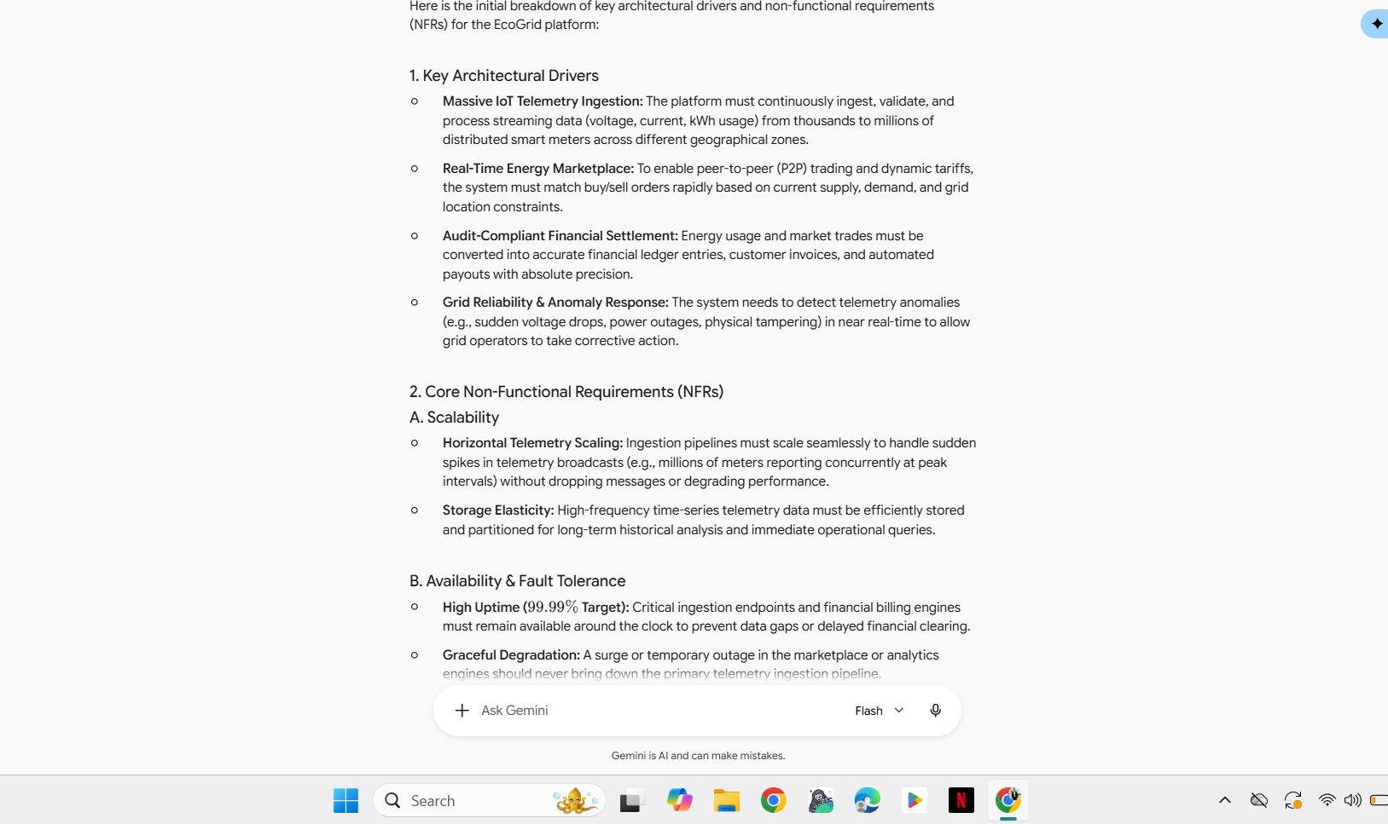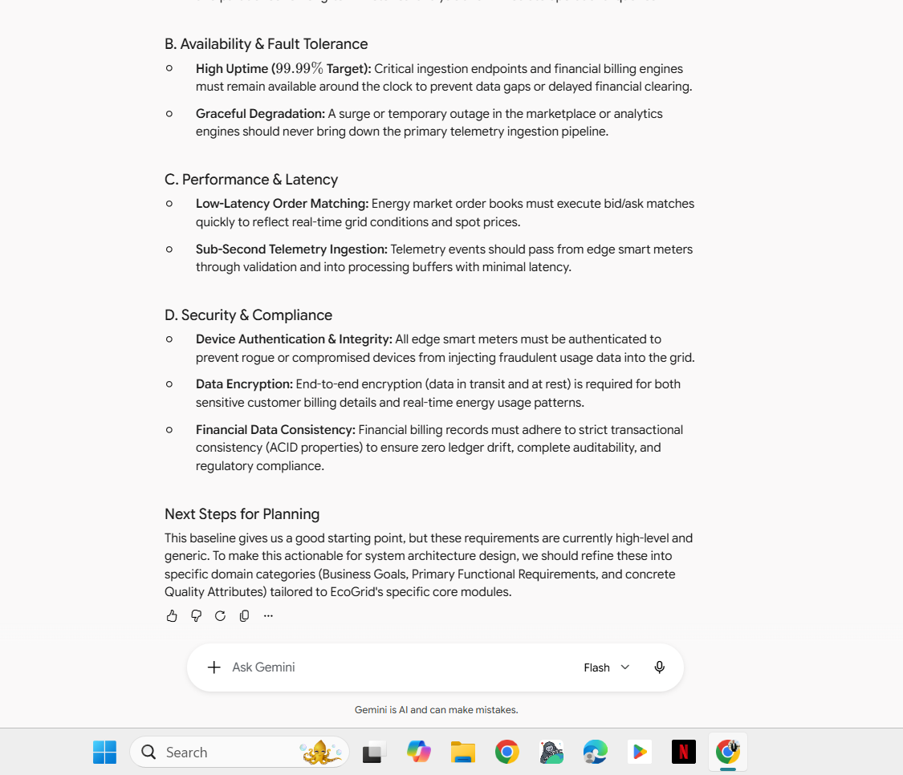

Screenshot 1,2 and 3: Initial prompts and Gemini’s response

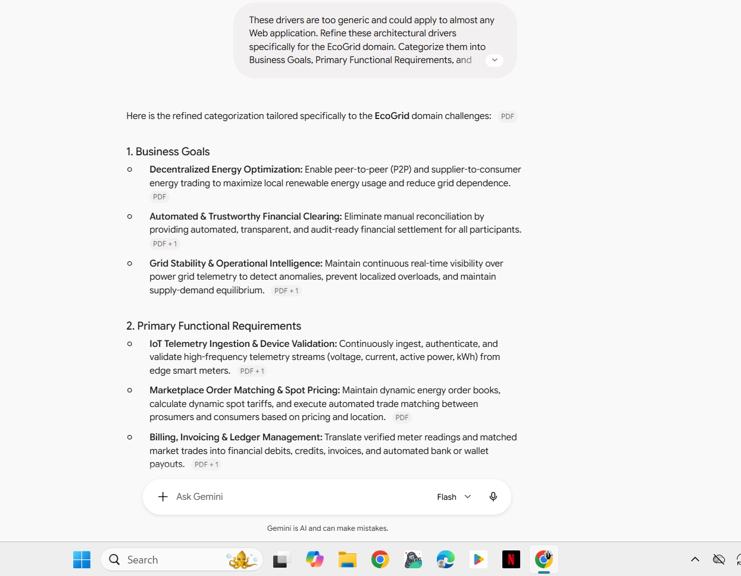

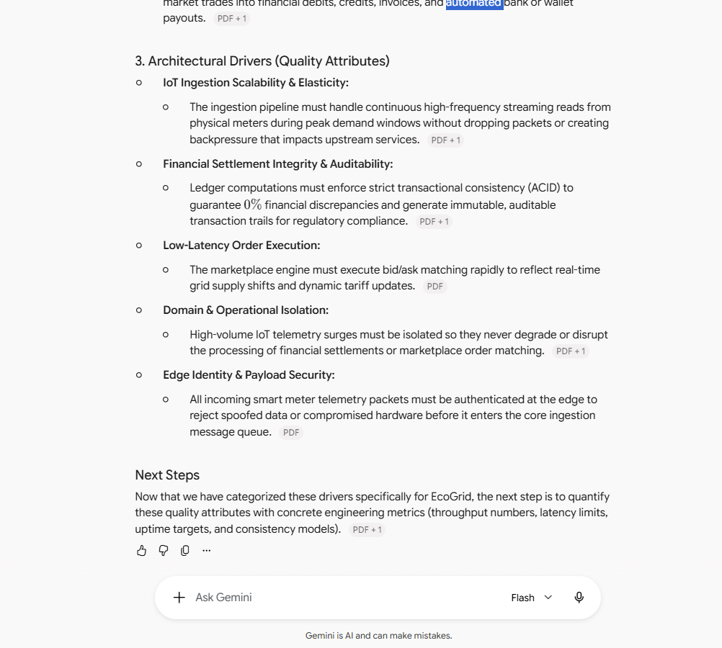

Screenshots 4 and 5: Refinement 1 prompt and response

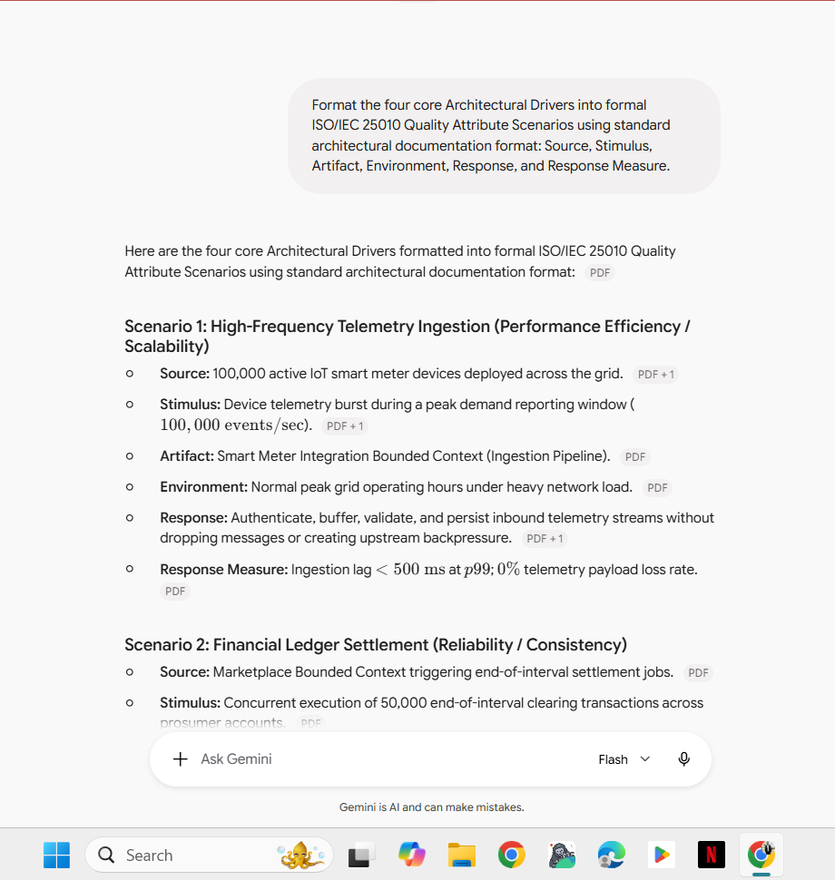

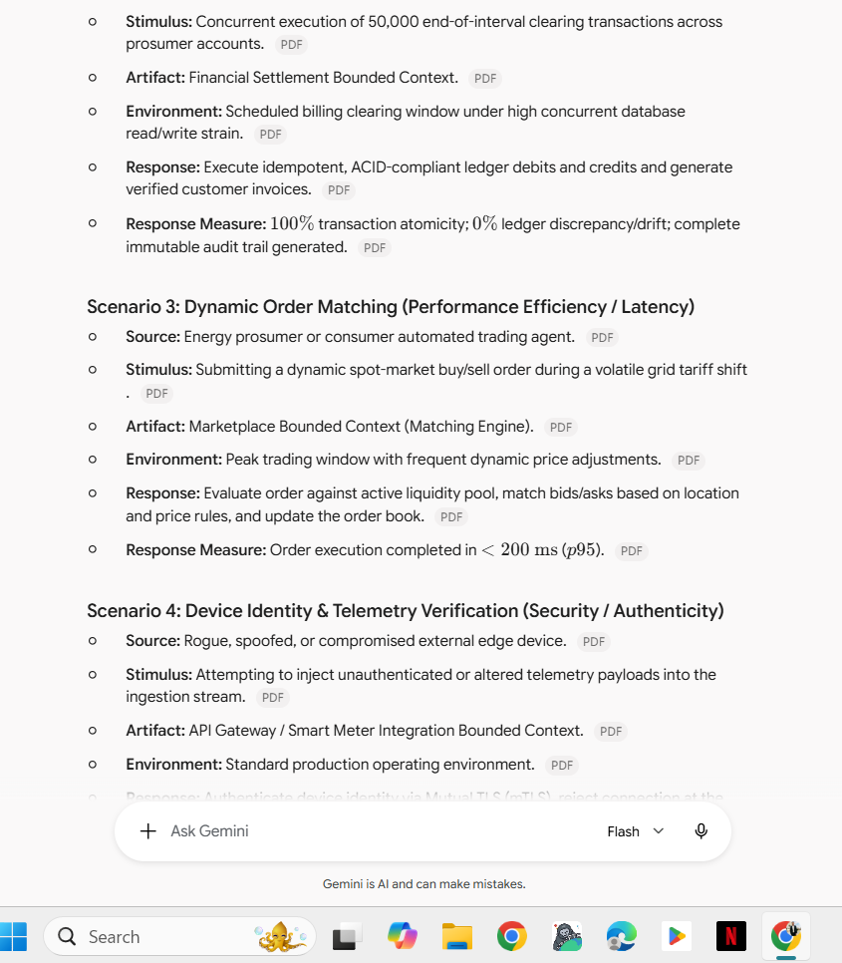

Screenshot 6 and 7: Refinement 2 Prompt and response

